05.05.2019



**MIDDLE EAST TECHNICAL UNIVERSITY**

DEPARTMENT OF ELECTRICAL AND ELECTRONICS ENGINEERING

**EE 7566** Homework #2

***IPMSM Finite Element Analysis (FEA)***

***with Ansys/Maxwell***

GÖKHAN ÇAKAL – **2332120**

# Question 1)

## 1)

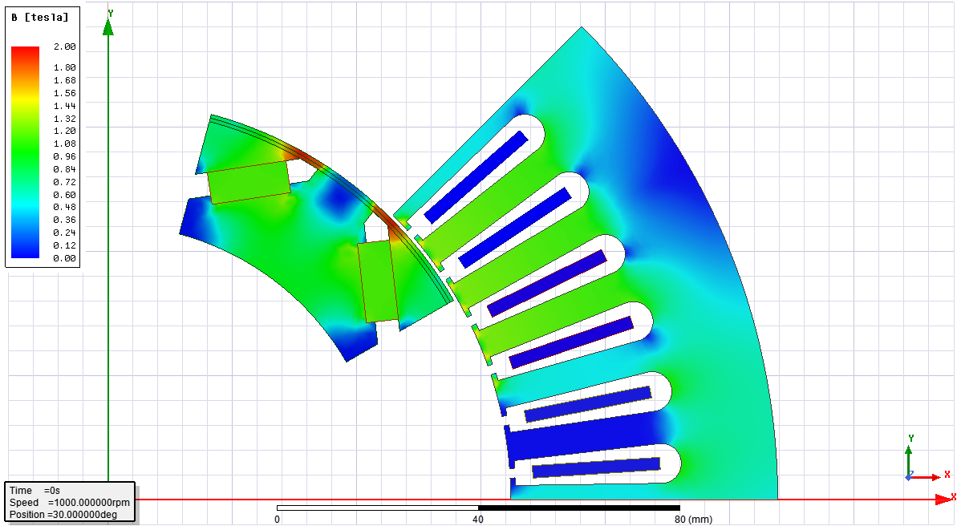

Figure 1: Magnetic flux distribution for no load case.

## 2)

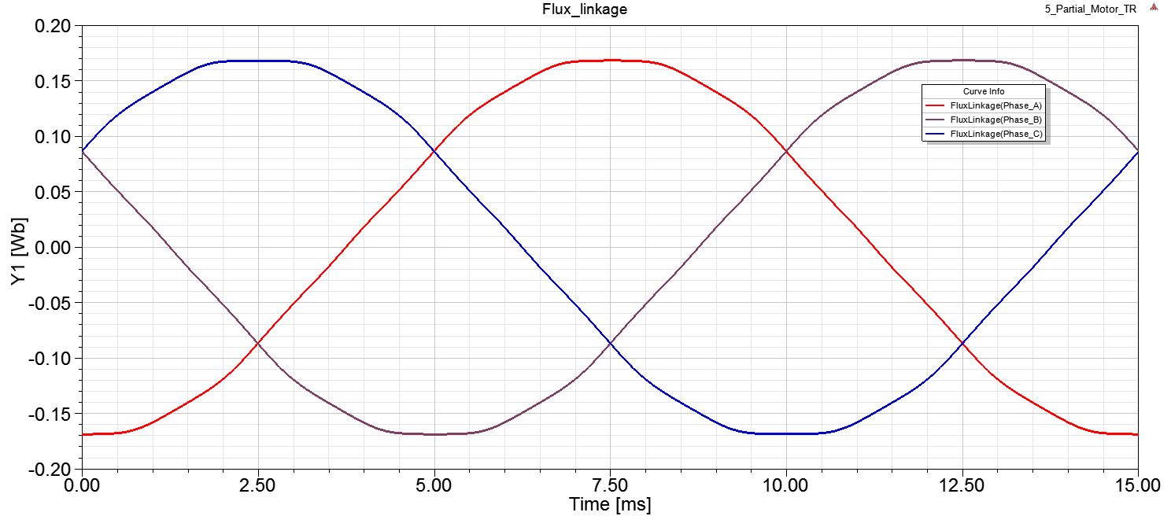

Figure 2: Flux linkages under no-load.

## 3)

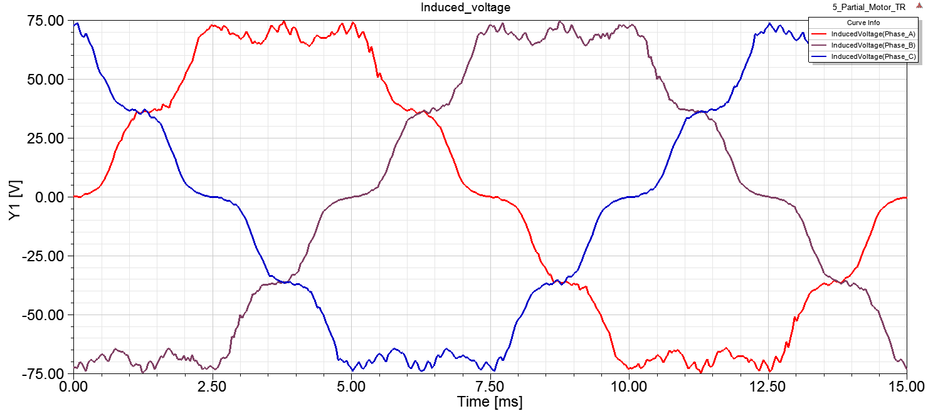

Figure 3: Induced voltages under no-load.

## 4)

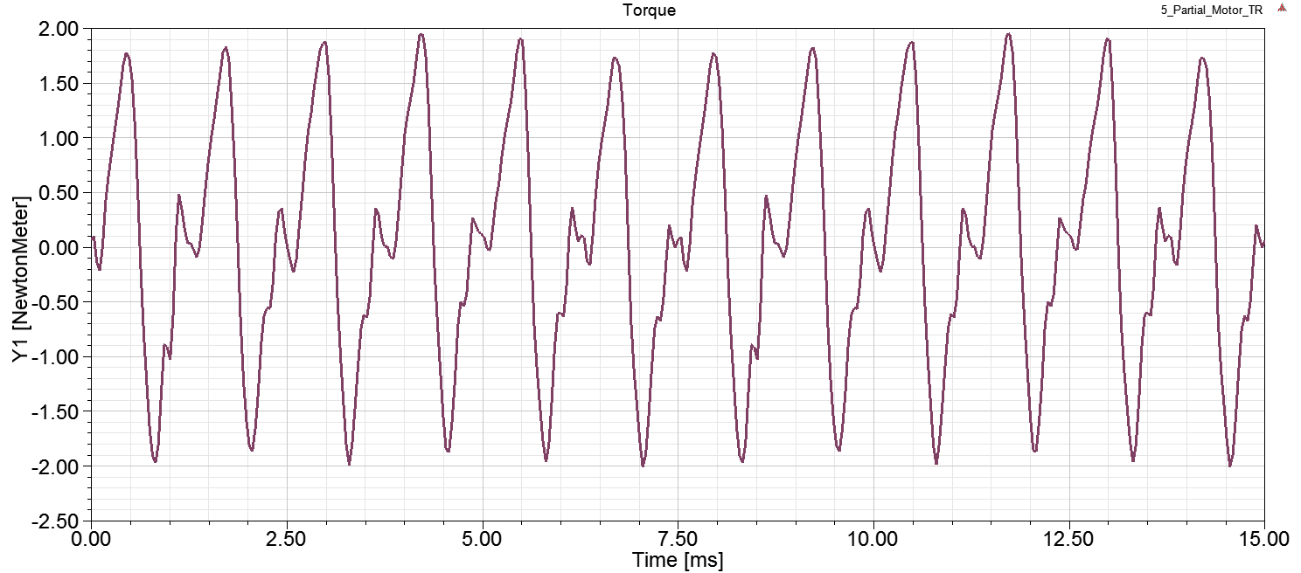

Figure 4: Torque produced under no-load.

## 5)

Here, we applied no currents to the armature and armature (stator) terminals are open circuited. Since there is no excitation, torque seen in Fig. 4 is actually cogging torque due to nature of rotor part of IPMSM.

# Question 2)

## 6)

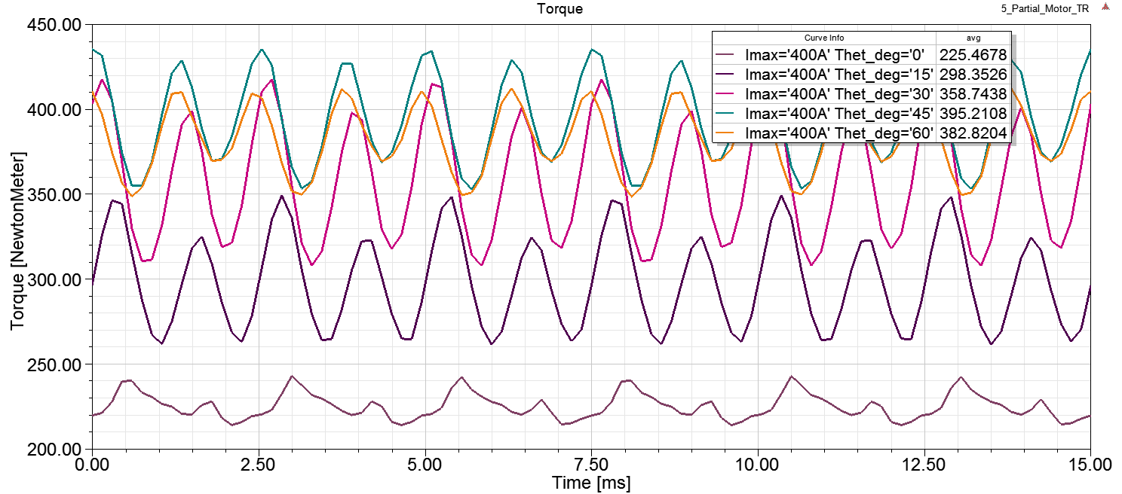

Figure 5: Torque produced with different load angles.

## 7)

In sweep analysis, it is shown that maximum torque is achieved at 45 degrees. There are two torque components for IPMSM: reluctance torque and magnet torque. Magnet torque is proportional with Id current and reluctance torque is proportional with Id*Iq current with following relation.



Also, load angle (theta_deg) shows how much Id and Iq current we supply to the system. Iq current is linear with sin(theta_deg) and Id current is linear with cos(theta_deg). Overall, magnet torque is proportional with sin(theta_deg) and reluctance torque is proportional with sin(2*theta_deg). Following figure explains this better.

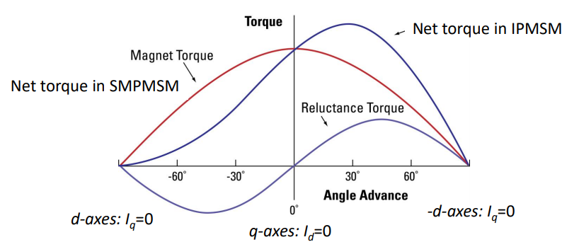

Figure 6: Variation of torque components of IPMSM with load angle.

In Fig. 6. it is clear that reluctance torque peaks at load angle of 45 deg. and magnet torque peaks at 0 deg. Thus, sum of this torque components peaks between 0 and 45 deg. depending on relative magnitudes. In our case, we observed that maximum torque is occurred around 45 deg. showing that reluctance torque is more dominant.

# Question 3)

## 8)

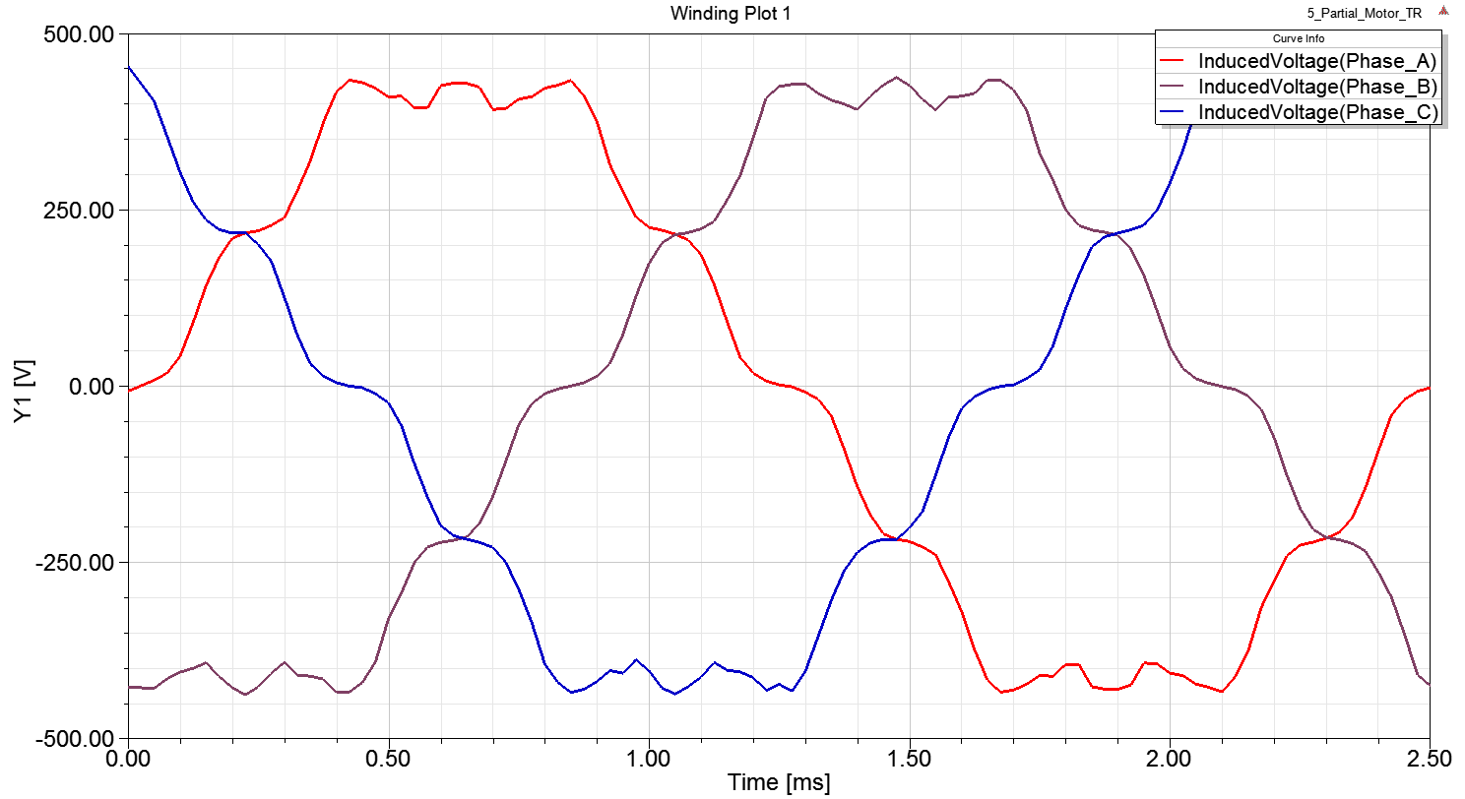 Figure 7: Induced voltages under field weakening operation.

## 9)

In Fig. 7, we observed induced voltages under no-load condition at 6000 rpm. To be able to drive this with operation point in previous part, we should focus on line-to-line voltage of the armature terminals to size inverter. Following plot shows line-to-line voltage in armature terminals.

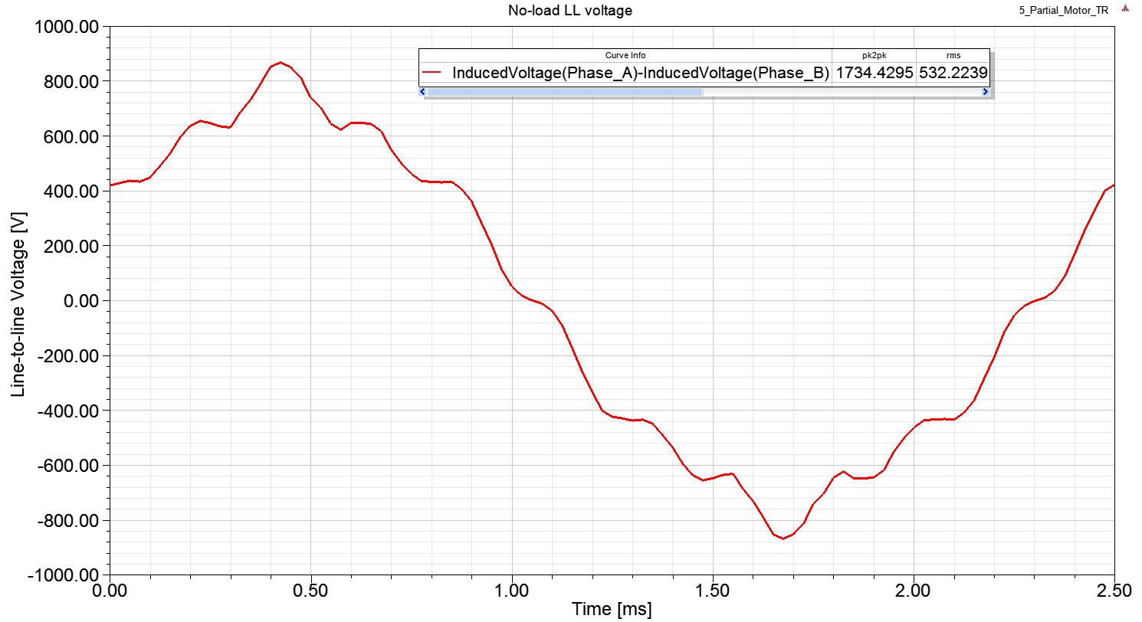

Figure 8: Line voltage for operation point in Question 8.

Thus, we can conclude that output of inverter voltage should be 1740 Vl-l and 530 V rms voltage.

## 10)

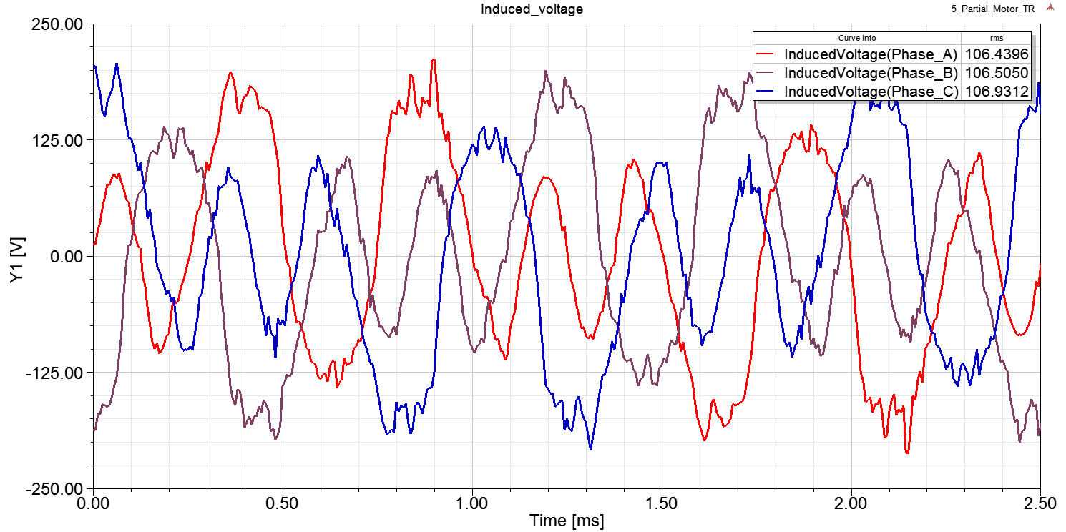

Figure 9: Phase voltages with –Id excitation only.

## 11)

First of all, since we apply only –d current, there is no torque component. Only cogging torque is observed. We know that Id is responsible for induced voltage. The more we apply Id, the more we get flux linkage and thus induced voltage. Applying –Id current results in reverse effect and creates flux with opposite direction of flux created by magnets. Thus, flux linkage by phase coils decreases, resulting in decreased phase voltages. Here, one should take attention to demagnetization levels of magnets.

## 12)

The torque equation for IPMSM is as follows



First element is magnet torque and second one is reluctance torque. We know that Lq is larger than Ld. Thus, applying –id current increases torque produced. One should note that both torque components directly proportional to the iq current. Thus, to produce net torque, iq current should be applied. Thus, applying only –id current does not result in net torque produced. This is shown in figure below.

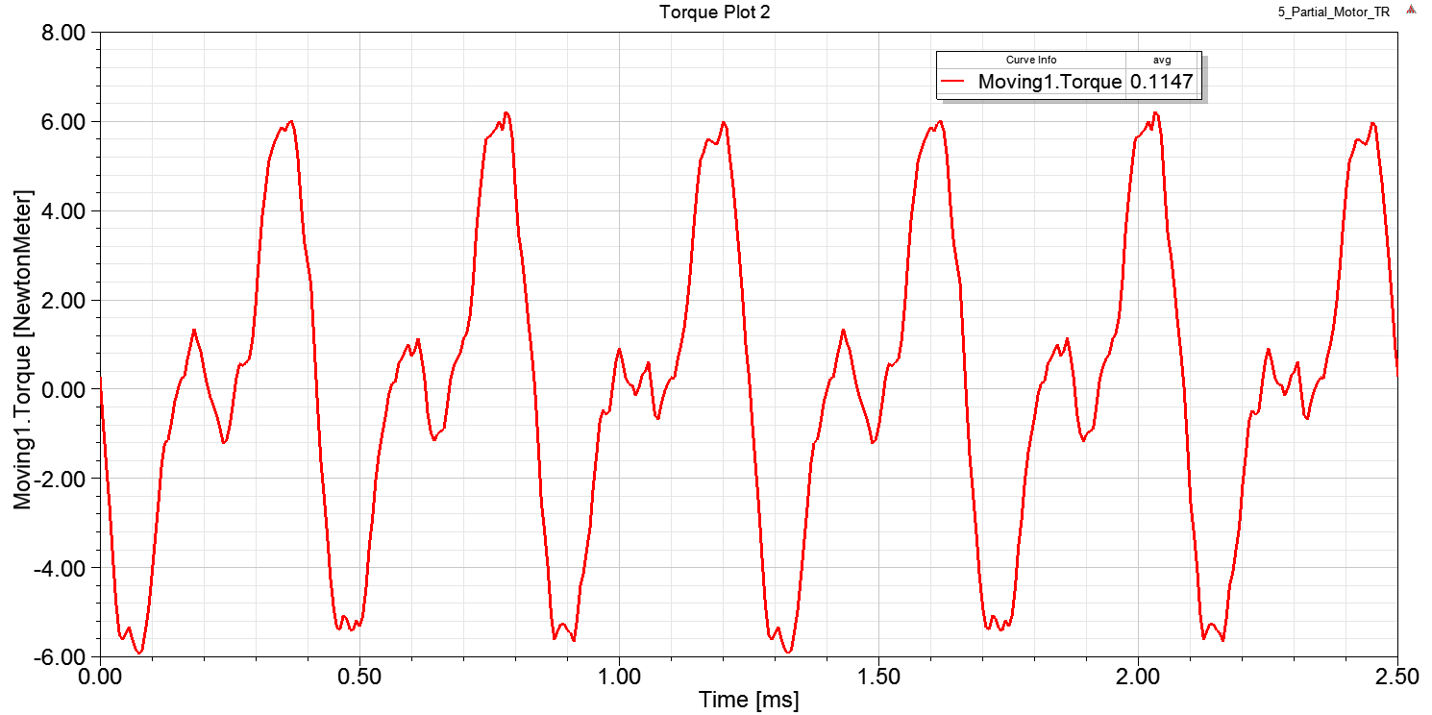

Figure 10: Torque produced when only –id current is applied.

Small torque observed above is cogging torque. Net produced torque is zero when only –id current is applied.